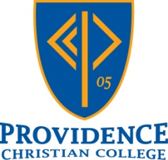
CSI Southwest Region
Future Christian Teacher Scholarship

Christian Schools International (CSI) has a strong tradition of supporting Reformed, Christian K-12 education in the Southwest, as well as internationally. The principals of the CSI Southwest Region have generously contributed to this scholarship fund in order to encourage Providence students interested in teaching in a Christian school.

This scholarship is open to current sophomore and junior education students.

Application Deadline: April 15

Application Requirements:
- A copy of your Providence unofficial transcript
- Recommendation from a Providence education professor
- Recommendation from one other person who you feel would best be able to speak to your potential as a future Christian teacher (former teacher, pastor, employer, etc)
- A completed application

Name _____________________________________ Student ID #: ____________

Hometown _________________________________ Year: Sophomore / Junior

Major _____________________________________ Year of Graduation: _______

GPA*: _______

*submit a copy of your college transcripts

Recommendations:
Ask two individuals to complete the recommendation form on your behalf (one must be an education professor at Providence). List the two individuals below.

1. ___________________________________ position: _____________________
Brief description of your relationship _________________________________________
________________________________________________________________________

2. ___________________________________ position: _____________________
Brief description of your relationship _________________________________________
________________________________________________________________________

Questions on Christian Education – each answer should be 250 words or less and typed on a separate piece of paper.

1. Where do you want to teach after graduation? Include location, type of school, grade level / subject area. Explain why.

2. Why do you want to teach at a Christian school? If you do not feel called to teach in a Christian school, explain why you feel called to teach elsewhere.

3. What has been the impact of Christian education on your life?

4. What experiences in your life have helped you prepare to be an effective Christian teacher?

